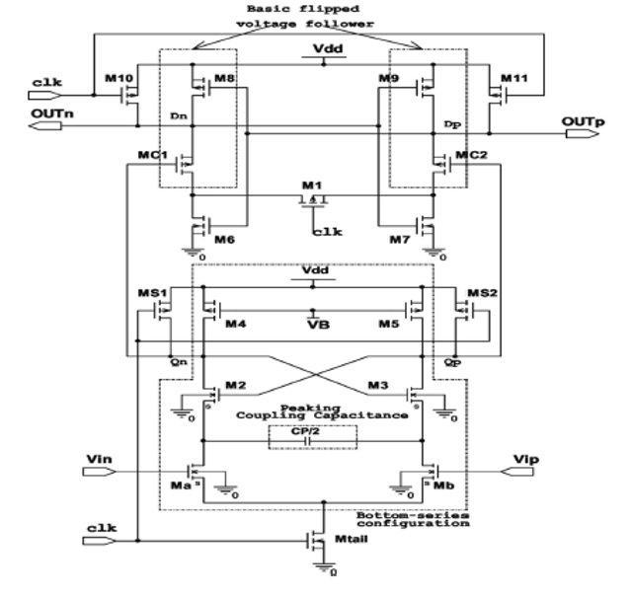

**Figure: Proposed circuit**

**Width of the NMOS and PMOS according to the table.**

